Perfect Connect 4 Algorithm
Michael Henson & Brandon Isaac

• Abstract: In 5 sentences or less briefly explain what the project is, any unique or interesting design
decisions or results, and whether the final product was successful.
• Introduction: Explain the background behind your project, including relevant history and why you
chose this project.
• Detailed Design: Provide detailed information on your team’s design. Include pseudocode explaining
the algorithm behind your connect 4 bot and diagrams to explain how it works.
• Results: Discuss the finished project. Was it successful at achieving all objectives? What interesting
discoveries did you make in the process? How could you improve this project further if you were to
continue working on this?
• Conclusion: Was the project overall a success? What would you do differently in retrospect?

Abstract
This projects was to design a program that could play Connect 4 perfectly. We decided to use an algorithmic approach so that the program could be used independent of anything else. The goal was for it to make optimal moves against players or another perfect CPU, and to not need an obnoxious amount of time to calculate. Our final program is successful in beating another perfect CPU when it moves first.

Introduction
Connect 4 is a solved game. This means that whoever goes first can guarantee to win if they play optimally. The game was first solved by James D. Allen in 1988. Since then, multiple solved version have been made. Some of these approaches are algorithm based while others are complete records of every possible move. We choose this project because it would provide a good challenge with a fun result.

Detailed Design
Our implementation uses a few existing concepts to calculate the best move. Since we can’t calculate all of the possible moves in a reasonable amount of time, we use these tricks to speed up calculations.
First was converting our 2D board array to a bit board. This allowed for faster calculations throughout our search. We used two integers to store the player and CPU positions on the board. The positions can be seen in figure 1 & 2.
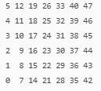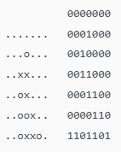
Figure 1 – Board Coordinates Figure 2 – Player positions and playable tiles
Next, we used a variation of the MinMax algorithm to simulate possible future moves and score them based on how likely they are to win. This is done with a recursive function that plays every possible move up to a certain depth. The best score from all of these simulations is found and that respective series of moves is executed.
Recursively generating each move get exponentially larger with each iteration. Just doing this would not let us have a very high depth. So we used some pruning to lessen the amount of branches that we had to simulate. One of these pruning methods is the Alpha-Beta Algorithm. The idea of this is that if you know a branch has a score of 10, and the one you are about to calculate next is lower than 10, there is no need to calculate that branch. So you skip it and move on. This cut off a large portion of the branches to calculate
The next function that saves time is the Transposition Table. This table stores the moves that you have already calculated for future reference. This prevents the same move from being calculated multiple times each turn of the game. The table stores the board state, the score that state was given, the depth when it was calculated, and the best move to make from there. Using this information, the program can decide what the best move is without recalculation all that information.
The last major time save we implemented was the opening book. This is a file containing all of the possible board states at turn 8. Each state also has a win/draw/lose score with them. This file was made by someone previously, but provides a massive head start to our algorithm. Without this book, the early game is when the program is most likely to make mistakes. Since the depth can only be set so high, it can’t see all the way to the end of the game. The opening book gives us a check point to hit part way. We know that if by turn 8, we can hit one of the winning states, that any moves to get to those states are perfectly optimized. The opening book we use is over 2GB of data. This is probably not very practical for normal use. I’m sure that it could be optimized down if desired.
Once all of these methods are combined, it allows our program to run 16 iterations deep while having only 1 minute of max calculation time. We felt that while that time could be reduced, that it was an acceptable standard for this project.
Bellow is provided a flowchart of our programs decision making
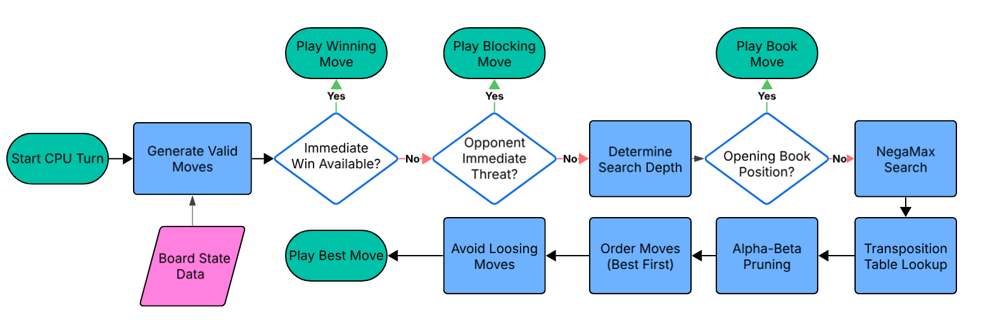
The code itself is laid out pretty simply. The game file contains the main order of operations for the game. The board file contains the board data and the operations to interact with the board. The validate input file is just for preventing wrong user inputs. The CPU algorithm is all of the CPU’s decision making code. And the opening book contains all of the 8th turn states and outcome.

Results
The process of developing the program was by implementing 1 step at a time. As we implemented smarter move making, we played against it to gauge it abilities. During this we learned about new methods that we didn’t know before. When it started beating us, we pitted it against an online program that plays perfectly. The result of this project was a CPU that beat the online perfect CPU when ours went first. We also played against it several times, and we weren’t able to beat it once. During gameplay, the longest it seems to take to play a move is around 1 minute. This was when it was against the perfect CPU. It usually plays faster against an opponent who makes non-optimal moves.

Conclusion
The end result of this project turned out better than we had expected. It beat the online perfect CPU that we had been comparing it too. The 1 minute calculation time could be reduced further, but we had to call it quits at some point. It would be impossible to test our program against every possible opponent in a reasonable amount of time, but we feel that beating the online perfect CPU, and beating us every time proves that it should be perfect. It would take longer that the deadline we had to test all 5 trillion valid connect 4 games. Aside from speed, the only thing that we could have improved was the UI of the program, but that doesn’t effect the ability of the program.

